#### CONTENTS OF THE GUIDE

* **HOW TO DOWNLOAD OR INSTALL THE APP**
* **LOGIN TO THE APP**
* **STATE-WISE TRACKING OF COVID CASES**
* **A QUICK SURVEY TO INDICATE YOU ARE SAFE OR REQUIRES COVID TEST**
* **ABOUT THE APP**

The main objective of this app is to make people aware about the active cases in and around the state of the GPS location of the user. It also helps to take the user a survey regarding the COVID-19 symptoms which helps to diagnose the COVID-19 case in particular area. The app uses all the data on a real time basis and collects the data of the survey to display the active case.

It tracks the positive cases in and around in states with the help of GPS, diagnoses status of the user and get to know all the data on a real time basis.

COVIDTRACKER USER MANUAL

### COVID TRACKER APPLICATION INTRODUCTORY

Your business ta line here.

#### THE APK FILE WILL BE DISPLAYED

After clicking on the WHATSAPP FILE, the APK file will be displayed and we need to click on that apk file now.

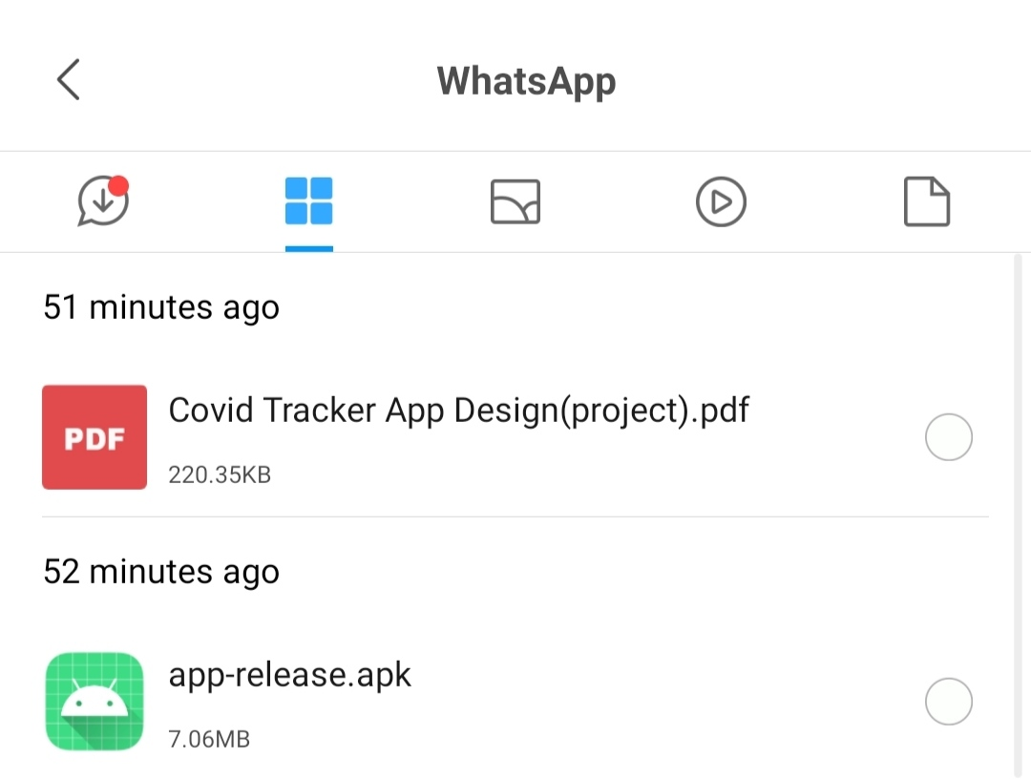

Now we click on the file to download the file and it will ask for the permission and after we allow the permissions, the file will be downloaded

#### CLICK ON THE WHATSAPP ICON IN FILE MANAGER

We have downloaded the APK file from WHATSAPP so, the downloaded file will be visible there.

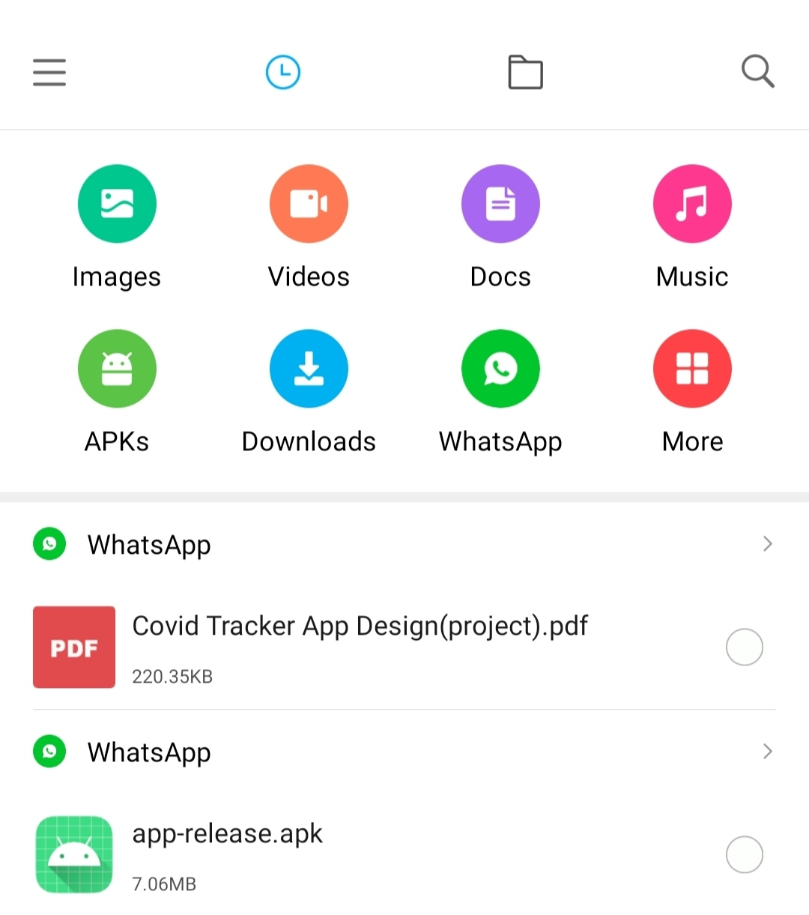

#### OPEN THE APK FILE USING FILE MANAGER

Click on the FILE MANAGER ICON in the phone



#### DOWNLOAD THE APP USING THE APK FILE

As this app is not launched in play store or app store, we will download the app using the APK file



### HOW TO DOWNLOAD/ INSTALL THE APP

#### COVIDTRACKER APP DOWNLOADING

Now the application is downloading after clicking on INSTALL

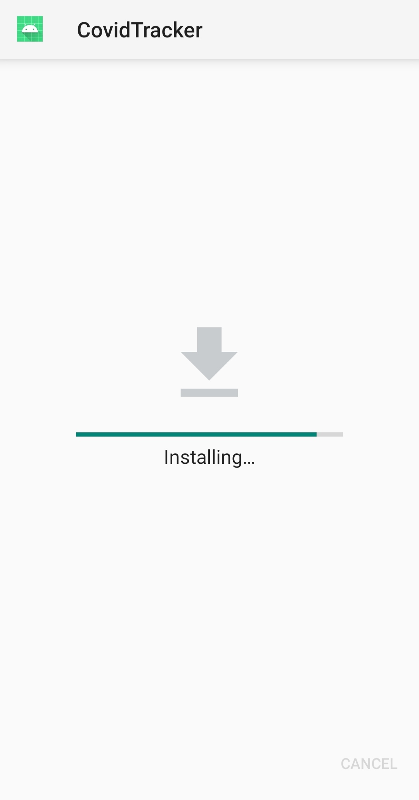

#### COVIDTRACKER APP IS DOWNLOADED

After the installation is done, we can see the COVIDTRACKER APPLICATION in our phone

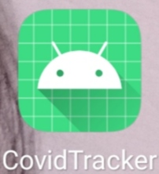

#### DOWNLOAD THE APK FILE AND CLICK ON INSTALL

After allowing the permissions, a page will be displayed to ask if we want to download the application and we have to click on INSTALL

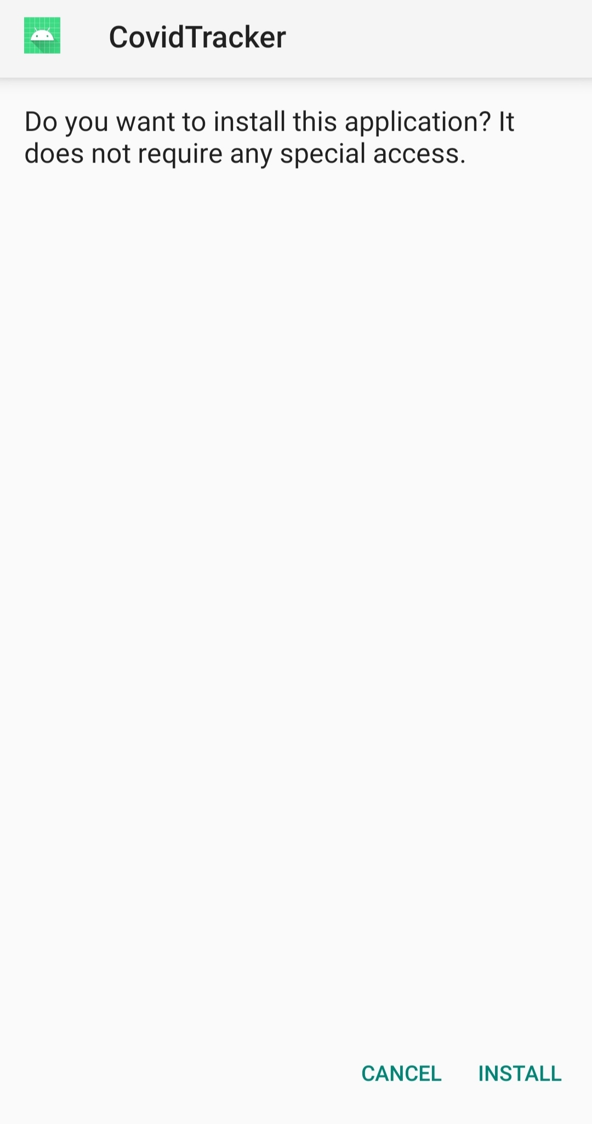

### HOW TO DOWNLOAD/ INSTALL THE APP

hggbjugvfdfgghbhftgdtjfkb

#### APPLICATION PAGE WILL APPEAR

When we login to the app, the main application page will appear which contains survey and tracking options.

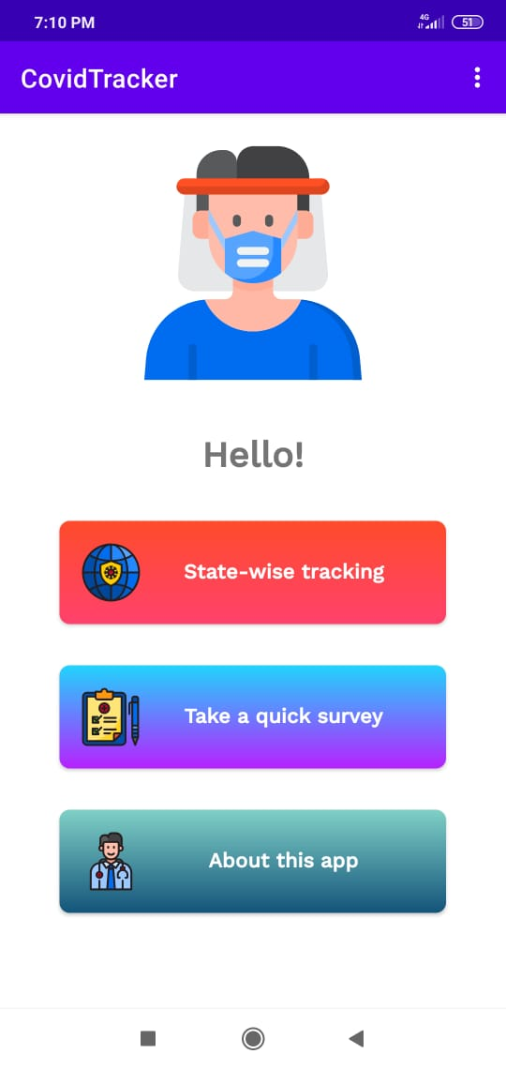

#### FILL UP THE DETAILS TO REGISTER TO THE APP

After clicking on the **NEW USER? CREATE AN ACCOUNT** , a page will appear in which we have to fill up the details and then login to the app.

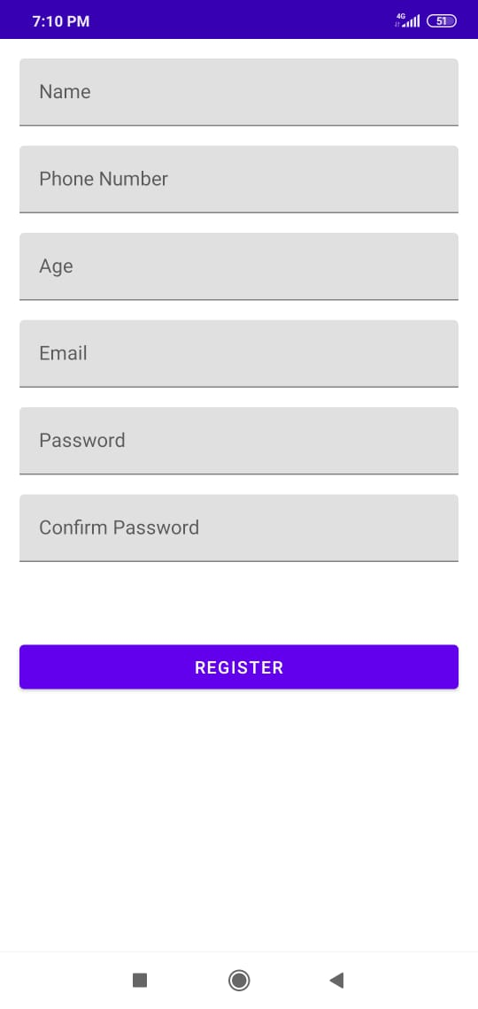

#### REGISTER TO THE APP IF YOU ARE A NEW MEMBER

After installing to the app, the first page that will open has login and signup option. We need to register to the app as the new member or login in case we are the existing member.

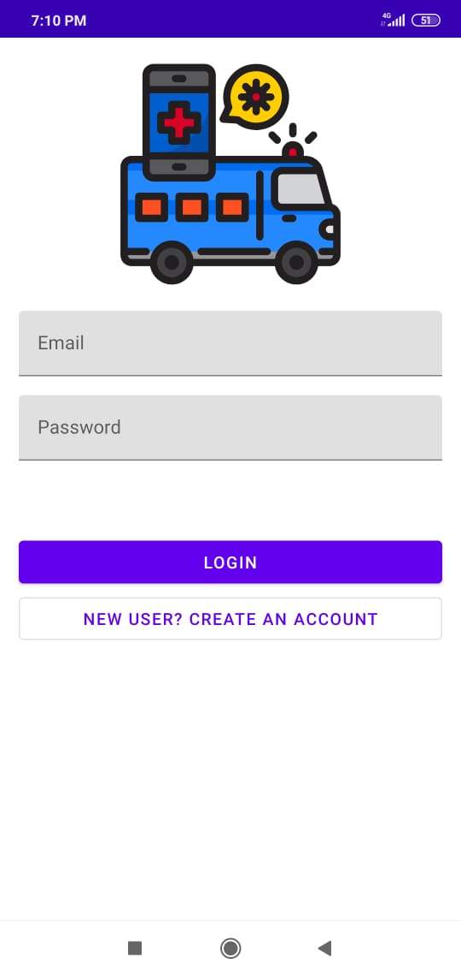

### LOGIN OR SIGN UP TO THE APP

#### CHECK THE COVID SITUATION IN DIFFERENT STATES

It contains area wise case details of different states. It contains confirmed, recovered, active, deceased cases.

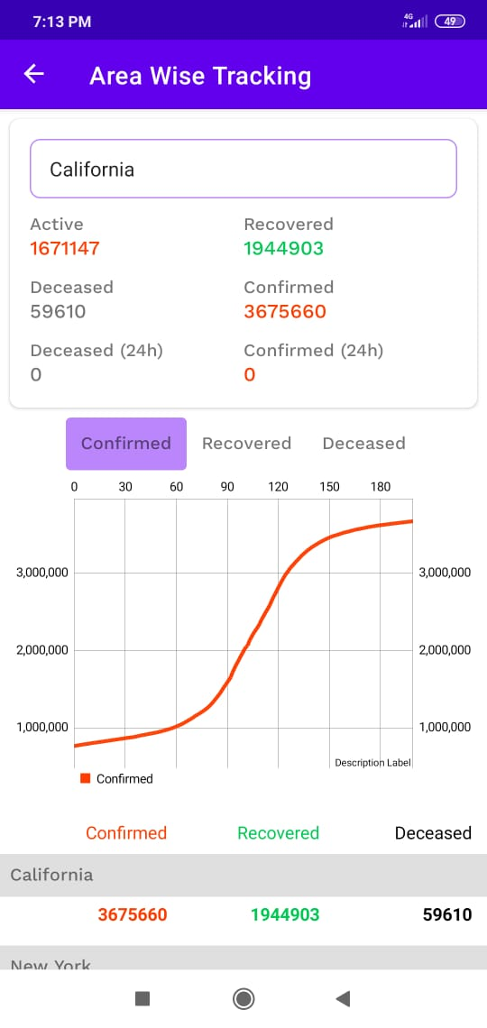

#### CHECK DETAILS OF DIFFERENT STATES GIVING THE INPUTS

In the input box we can give input of the names of different states and check the case status.

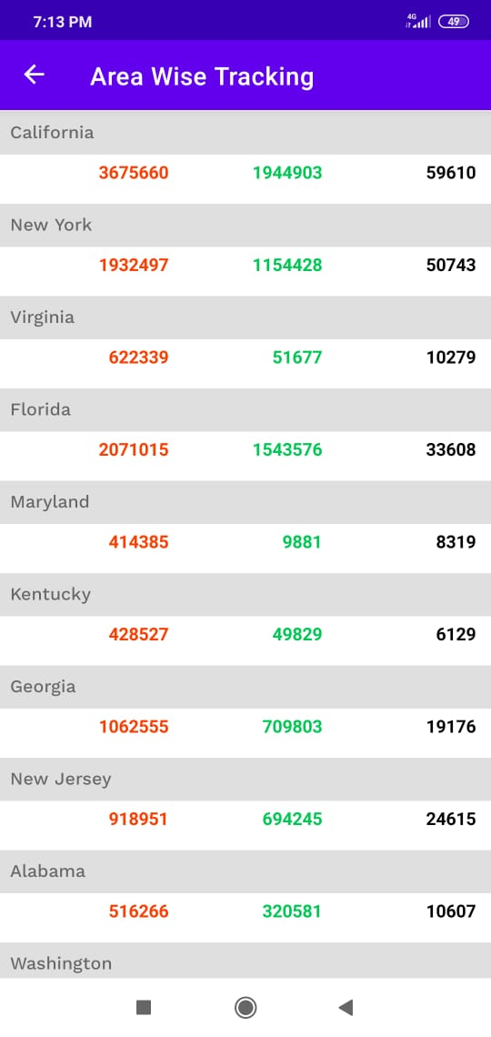

### STATE-WISE TRACKING GUIDE

#### FILLUP THE SURVEY FOR NO SYMPTOMS

After taking the survey, it tells us the status of covid cases and when the user is facing no symptoms then it tells the user has no symptoms and the user is safe.

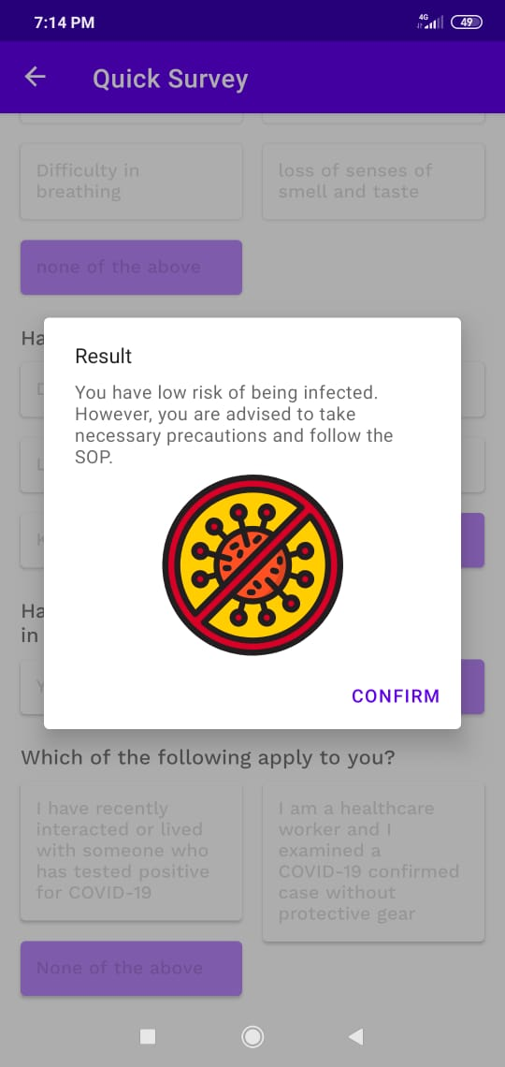

#### FILLUP THE SURVEY FOR MILD SYMPTOMS

After taking the survey, it tells us the status of covid cases and when the user is facing some symptoms then it tells the user has mild symptoms and requires COVID test.

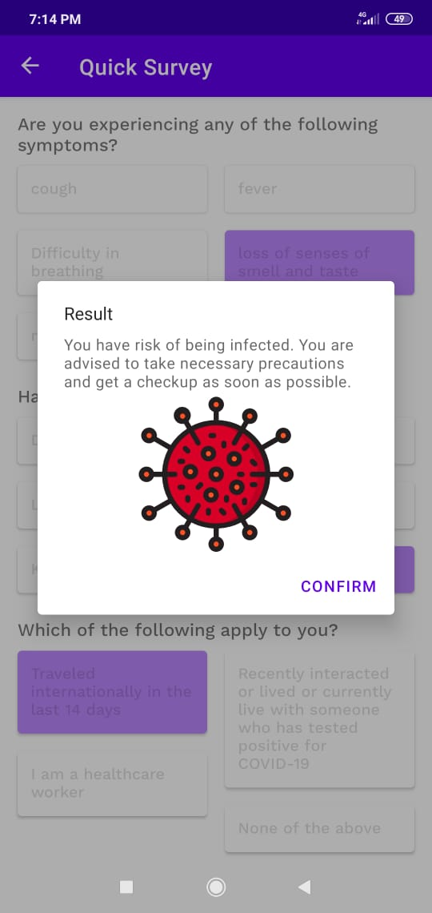

#### FILLUP THE SURVEY DETAILS TO DETECT IF YOU ARE SAFE OR NOT

After login with the help of username and password, the next page that opens is of a survey that helps the user to diagnose whether the user is suffering from covid or not.

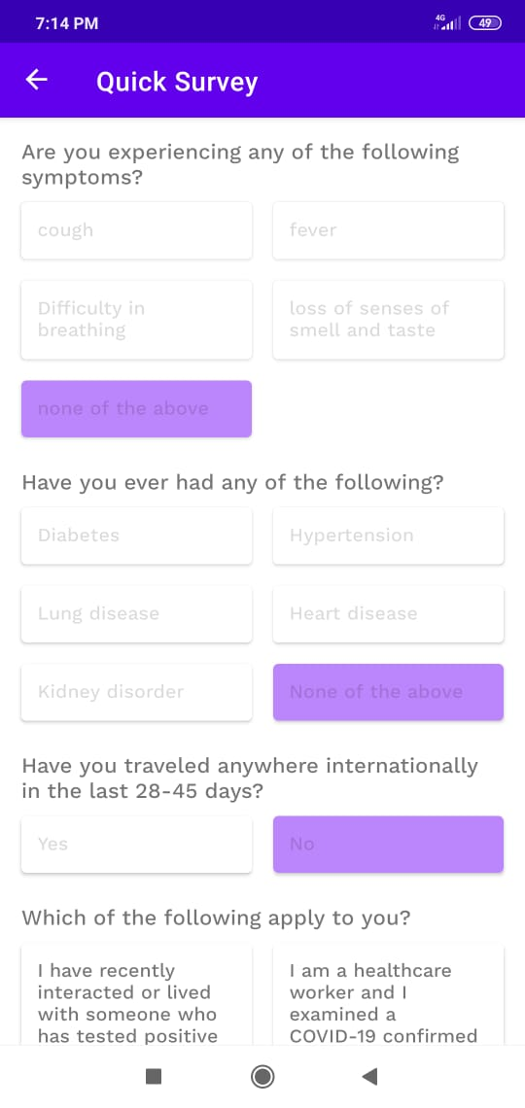

### QUICK SURVEY PAGE GUIDE

#### RECEVING THE TRACKER NOTIFICATIONS AFTER THE USER DATABASE IS LOADED

After we sign up to the app as the new user our database is stored in the app and we are able to receive the notifications regarding the active and inactive cases to our nearby location. It lets the user to know about the new active cases in the areas within a radius of 500 meters.

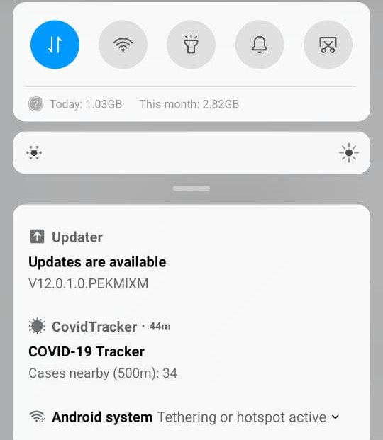

### NOTIFICATIONS OF THE TRACKER DATA

#### CLICK ON THE LOGOUT OPTION AND YES TO GET OUT OF APP

By clicking on the logout option, a dialog box will be popped and yes option will be clicked to logout and get away from the page.

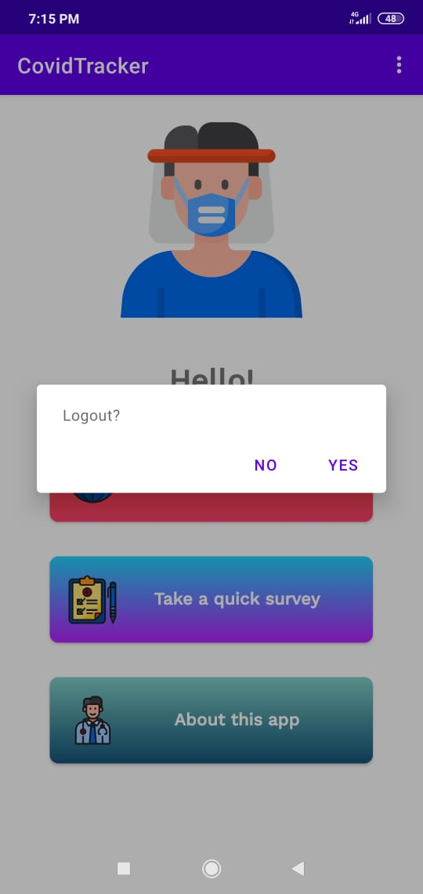

#### CLICK ON THE TRIPLE DOT OPTION (MENU OPTION)

By clicking on the menu option, we will get the log out option and the user will get out of the tracking page and user info.

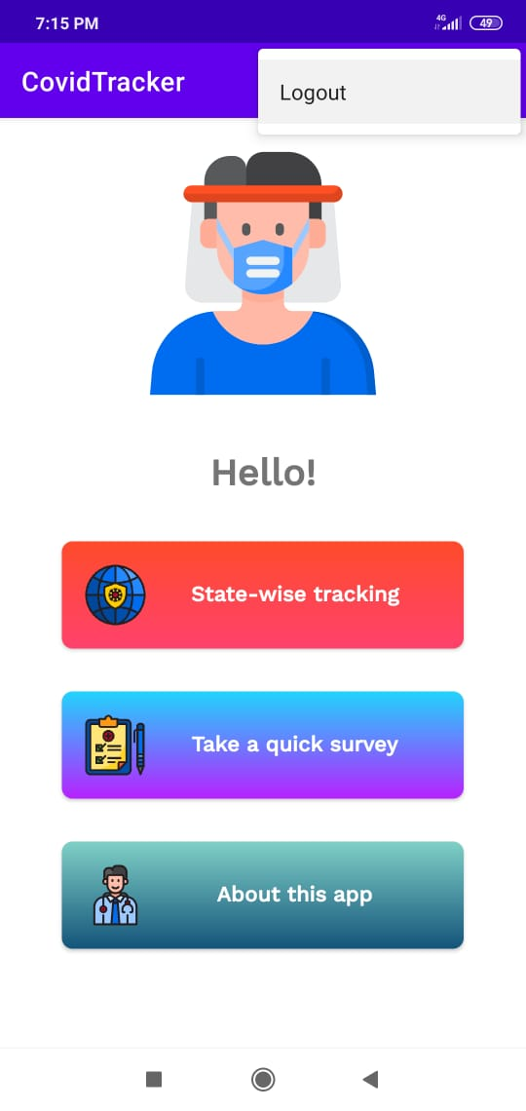

### LOGOUT OF THE APP